# Before you get started with users [+4]

1. **[+1] As a group, discuss any assumptions you have about your users or usage contexts.**

**Consider aspects such as language, age, dis/ability, indoors/outdoors, alone vs. small group vs. family vs. large social gathering, etc. Write a summary of your discussion and a clear statement of your assumptions going into user research.**

During our group discussion, we had assumed that, given who we knew as candidates to interview and our own experiences, many of our users would primarily have English as their native or their second language, with either one or two additional languages learned by them. We also expected our users to be around 20-30 years of age, and during their language learning period, utilized various apps and websites such as Duolingo to assist them.

2. **[+1] As a group, share any hunches you want to test or unknown/open-ended questions you want to answer through user research. Summarize your discussion, listing out 2-3 things you want to learn through user research.**

In our group, we believed that the main strategies that our interviewees would use would be using various apps like Duolingo, consuming media content, or speaking with native speakers. We specifically wanted to learn if users utilized them, how they helped/did not help, and what specific properties they felt were lacking in these tools. Additionally, we were also interested in why they decided to learn secondary languages, since while some languages we felt were learned solely due to undergrad requirements, others may have been learned mainly due to their families speaking that language.

In the end, the most important things we want to learn through user research are as follows:

1. What resources did they use while learning their language? What are some of the pros and cons of these resources, and what they would wish that could have existed?

2. What was their motivation for learning a second language, and how does it influence their learning progress?

**3. [+1] Based on your discussion above, pick a method/s. Write 1-3 sentences justifying your methodological choice. You can employ multiple methods or just one. Make sure your response answers: How are these methods going to help you understand the problem you are trying to address? How will each method allow you (or prevent you) from reaching users of interest?**

Overall, we have decided to go forward with a mix of interviews and surveys as our methodology, since this will get us a good amount of information on language learning from the interviews while also supplementing and getting a wider breadth of information from the surveys.

Given the fact that our interviews span from 30 minutes to 1 hour, the survey (which takes around 10 minutes to complete) is used as an alternative for people who perhaps cannot devote the time for an interview, letting us get valuable information from a wider range of people.

Both our surveys and interviews will include various questions (with interviews going more in-depth) about their motivations for language learning, any resources they used and what they liked/disliked about them, and what they personally want out of a language learning resource.

**4. [+1] Write your user research protocol. Consider the following:**

* **Recruitment strategy (e.g., whom to contact, how to contact, how many)**
* **Time and place for each user research session (e.g., “in the afternoons, in person, in a meeting room”)**
* **Each member’s role and responsibilities (e.g., For interviews: interviewer, note-taker, discussant, etc.)**

For our research protocol, we have prepared a set of interview and survey questions to provide to potential interviewees and surveyees. Questions include discussions on what languages users have learned and their proficiency in various modalities (reading, writing, speaking, listening), resources that they used, strengths and shortcomings of those resources, and what resources they would like to have if they are still learning/wished to learn a language again.

For this project, we focused on recruiting a variety of individuals, starting with friends and family members that each team member knew, as well as encouraging them to send out the survey/requests for interviews to their own friends. We also plan to gain potential interviews and survey responses from members of various language clubs at UCLA, given such members likely have experience or are interested in learning secondary languages.

Interviews are conducted through Zoom, phone call, or in-person, depending on the interviewees' preferences. The time interviews are conducted are also determined and agreed upon by the interviewer and interviewee.

Overall, we plan to have at least 10 interviews, or, in the case of a mix of surveys and interviews, at least 7 interviews and 15 survey results. Our ideal scenario would be double that amount.

For each interview, there is generally only one team member present. As such, each team member acts as the interviewer, note-taker, and discussant for the interviews that they hold. If on Zoom, the interviewee can ask for consent to record the Zoom interview in order to provide a record for later use.

# Conducting user research [+5]

1. **Write and submit ~0.5-1p of notes for each user research session OR initial analysis of survey results**

We have 10 interviews and over 30 surveys. Notes for interviews and survey analysis are provided in the github folder titled ‘Interviews and Surveys.’

Here are some rough guidelines for how many users you should reach:

- 10 users/groups of users for interviews

- 25 users/responses for surveys

- 5 users to conduct contextual inquiries that are at least 1 hour in duration

- some combination of the above (talk to instructor to make sure that you're reaching enough potential users)

**# After you get started with user research [+4]**

1. **[+2] Synthesize your user research into:** 
   1. **[+1] Personas + Scenarios (at least one persona, one scenario)**

From our user research, we have two personas:

1. Heritage Speakers
   1. Strong listening, speaking
   2. Poor reading, writing
2. People learning from interest in culture or society, or are learning for school or their career
   1. Limited exposure outside of media (less direct practice than na
   2. Compared to Heritage speakers, often more balanced in the modalities

Additionally, we derived two scenarios that these personas may find themselves in:

1. The speaker wants to travel to a foreign country that speaks the language of interest
2. A Language learner who is at home studying their language of choice
   1. **[+1] Process map or more in-depth task analysis (at least one)**

We have the following process maps for each scenario and how each persona might face them.

Travel to a foreign country that speaks the language of interest

1. Heritage speakers might not be able to read all the signs, menus, documents etc
2. People learning from interest may not be as confident in their speaking to actively engage with locals. What they learned from textbooks does not translate well to real conversations.

Language learner is at home studying their language of choice

1. Heritage speakers speak with their family, but it’s harder to practice writing and reading
2. Non heritage speakers are listening to youtube videos, shows, or songs to gain their immersion in listening. They don’t have a person to talk to unless they seek out social clubs or online communications tools.They’re learning from textbooks or apps like Duolingo, except a lot of their curriculum does not align with their language goals, such as conversational topics or slang.
3. **[+1] Articulate a problem statement. A problem statement should illuminate the core of the issue you observe. Often, there is a contrastive tension between what users want to do and what their current tools require them to do. If you cannot articulate this yet, describe why you think you are not able to converge yet, what promising directions to follow up with additional user research and feedback might be, and what steps you think you should take next.**
   1. **Tip: Rely on your process map. What is it telling you about what users want to do vs. have to do?**
   2. **Double check: Does your storyboard communicate/highlight this core tension?**

We have two problem statements, one for each of the personas we mentioned:

**Heritage Speakers:**

Heritage speakers are familiar with speaking and listening modalities due to their exposure to family and friends, but often lack proficiency in writing and reading. Outside of home or their circle of friends, they often lose practice with their heritage language and so may forget over time.

**Non Heritage Speakers:**

Non-Heritage speakers typically lack opportunities to practice or engage with the language they are learning, and some of the resources, like formal textbooks or Duolingo, may not be immediately useful in areas like casual conversation. Without opportunities, consistency may decrease due to perceptions like lack of time commitment. They may also feel self-conscious about their proficiency in the language, which limits them from seeking out opportunities.

1. **[+1] Storyboard of how your proposed system could address the core problem. This is where you begin to imagine a prototype to address the core problem you identified.**

We’ve completed our storyboards on physical paper and will be presenting them in-class. We’ve also uploaded them in a folder called ‘Storyboards’.

* 1. **DEPTH (optional, not required) [+1]: Map out a design space of existing tools (production or research) for supporting similar tasks x users x domains. Your design space should include at least five other comparable tools.**

Our design space map is shown below.

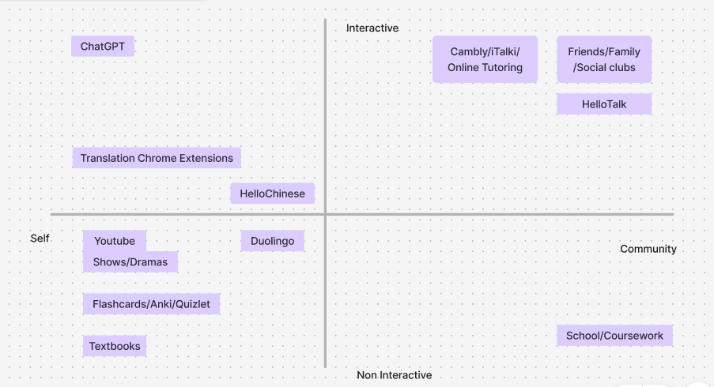

***# Communicate what you have learned [+2]***

1. ***[+2] Draft blog post summarizing user research. Your blog post draft must include:***

***- A description of methods and key findings***

***- A clear problem statement describing the crux of the issue you identified through user research.***

***- Your storyboard***

***- At least 1 figure that is not from your storyboard***

We will be submitting this at a later date after our in-class crit.

1. ***DEPTH (optional, not required) [+2]: Pick a model research paper with a formative study. Write your user research as a formative study section. In your submission, specify your model paper and why you chose it.***

**# Reflection [+3]**

1. **[+1] Look back at your assumptions (in the “Before you get started with users” section). Has your user research contradicted or challenged any of these assumptions? If so, which ones? How?**

Looking at our surveys, we noticed that less people put “motivation” as one of their top challenges than we expected. From our interviews, we think that this is because many people attribute their inability to learn consistently to an increase in outside factors (work, school, etc) rather than a decrease in intrinsic factors.

1. **[+1] What does your user research tell you about what kinds of interactive systems/solutions are unlikely to be useful/successful? Why not? Any hypotheses about what features of an interactive system will be useful? Why?**

Many of our users tried Duolingo, which is a very successful app for learning languages. The gamification was good for beginner learners, but many people felt that they could not learn much to contribute to an active conversation. The same was true for many conventional learning methods such as textbooks or rote learning from school. People felt that the content was not applicable to real conversations, and many of them had limited access to native speakers for practice.

One hypothesis about a successful interactive system to drive successful learning is some way for people to learn conversational grammar and vocabulary, and be able to practice that continuously. The end goal should be to bootstrap users into conversational interactions in order to use what they have learned in the real world. We feel that an LLM would be useful as a persona to converse with and teach languages.

1. **[+1] What questions do you have about your users? What hunches or hypotheses do you have about promising solutions? What is one thing you can do to begin answering these questions?**

We have the following questions about our users:

Would using an LLM or chat bot help alleviate some of the nervousness when it comes to practicing a foreign language?

Would you be more willing to practice more often if you had a chatbot that you can use for your convenience?

One thing that we can do to begin answering these questions is to come up with a proposed solution and interview learners about their thoughts.

1. **Did you use a generative AI tool for any part of this assignment? If so, which one and how?**

We used generative AI to draft a script to ask for consent in a clear and consistent way for interviews.

1. **How much time did you spend on this assignment as a group? Individually?**

We spent around 5 hours reaching out and interviewing people individually.

As a group, we spent 3-4 hours reviewing the results of the interviews and compiling and cleaning data from the surveys, 2 hours to come up with personas and scenarios. and an additional 2 hours to complete the storyboard.